V2X-Based Cooperative Perception for Enhancing Autonomous Vehicle Safety at Urban Intersections
AL-DHANEBI ABDULMAJEED TAWFIK AHMED YAHYA
Student ID: 312024705005
Major: Software Engineering
1. Introduction and Application Context
Vehicle-to-Everything (V2X) communication is an important technology in smart transportation systems that enables information exchange between vehicles, infrastructure, pedestrians, and network systems. Among different V2X applications, cooperative perception is considered a key approach for improving the environmental awareness of connected and autonomous vehicles.
This case study focuses on V2X-based cooperative perception at urban intersections. In this scenario, vehicles and roadside infrastructure cooperate by sharing sensing information to create a more complete understanding of the surrounding environment. Unlike traditional autonomous vehicles that mainly depend on onboard sensors, cooperative perception allows vehicles to receive additional information from external sensing systems such as roadside units (RSUs).
Urban intersections represent a challenging environment because many potential hazards can be hidden by buildings, vehicles， or other obstacles. By combining vehicle-based perception with infrastructure-based sensing, V2X systems can extend the perception range and provide earlier warnings for dangerous situations.
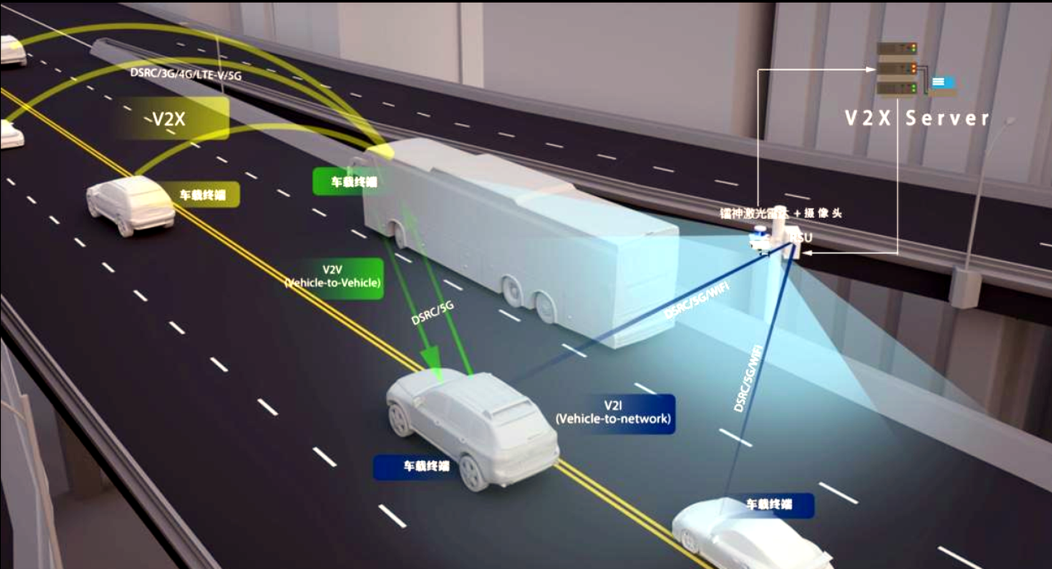
Figure 1. Example V2X roadway communication scenario showing V2V, V2I and RSU/server interactions.
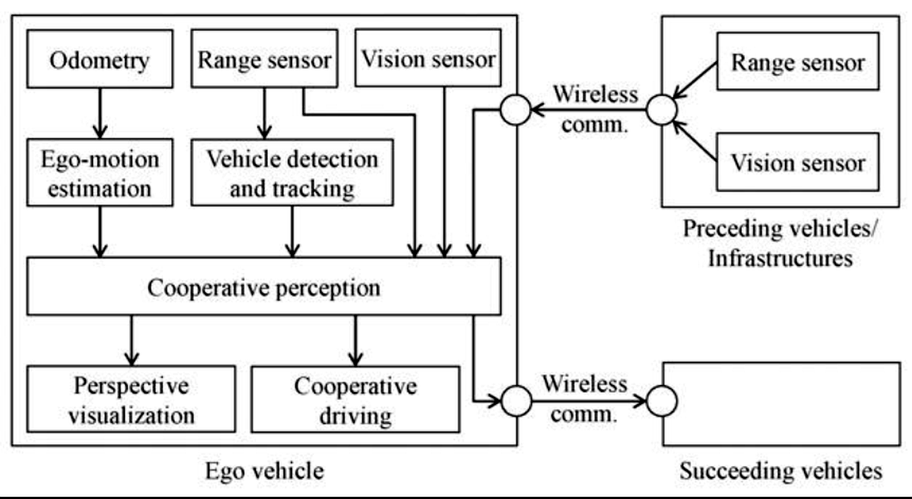
Figure 2. Cooperative perception framework showing ego-vehicle sensing, wireless communication and cooperation with vehicles/infrastructure.
2. Main Problem Addressed
Although modern autonomous vehicles are equipped with advanced sensors, individual vehicles still have limitations in understanding complex traffic environments. One major limitation is the occlusion problem. For example, a pedestrian or another vehicle may be hidden behind a large vehicle or roadside object, making it impossible for onboard cameras or LiDAR sensors to detect them directly.
Another challenge is the limited sensing range of individual vehicles. A vehicle can only observe the environment from its own position, while roadside infrastructure can provide additional viewpoints from different locations. Furthermore, urban environments may cause localization difficulties because buildings and other structures can reduce GNSS accuracy and increase positioning uncertainty.
V2X cooperative perception addresses these problems by allowing vehicles and infrastructure to share environmental information. Instead of relying only on local sensing, connected vehicles can obtain a broader and more reliable perception of the traffic environment.
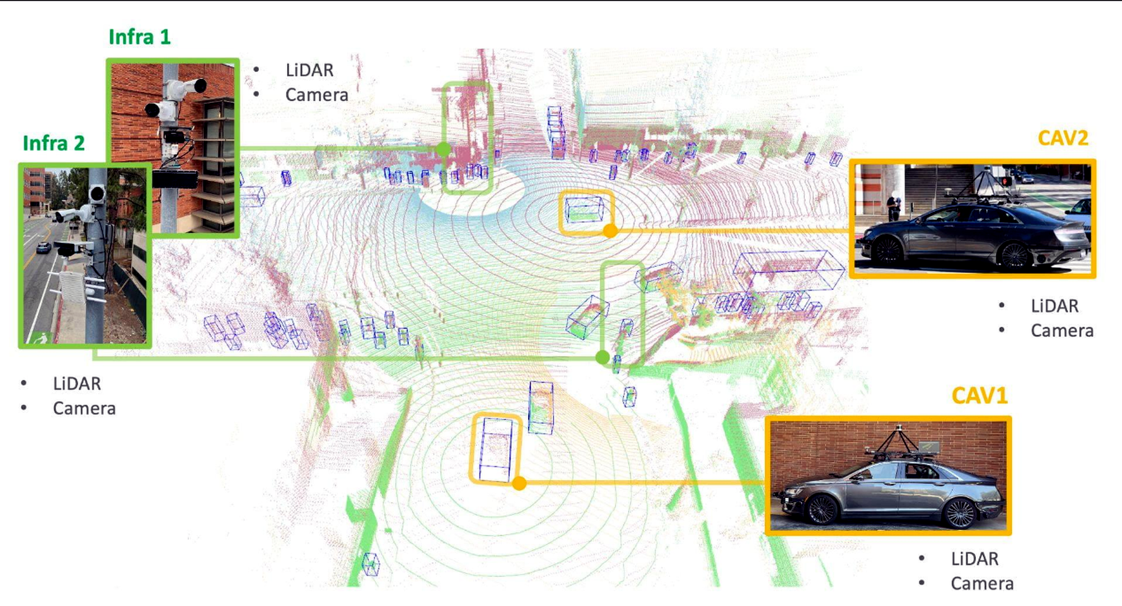
Figure 3. Cooperative perception example with infrastructure sensors (LiDAR and camera) and connected autonomous vehicles (CAVs).
3. V2X Technologies, Sensors and Data Involved
The cooperative perception system consists of communication technologies, sensing devices and data processing methods. In a typical V2I (Vehicle-to-Infrastructure) scenario, the roadside unit (RSU) collects information from infrastructure sensors and communicates with the vehicle through V2X technologies. The vehicle receives this information through its onboard unit (OBU).
Modern V2X systems can use technologies such as C-V2X and 5G-based vehicle communication to support low-latency information exchange. Reliable communication is essential because safety-related applications require rapid and accurate data transmission.
Multiple sensors are involved in cooperative perception. LiDAR is widely used because it can generate accurate three-dimensional point clouds and provide information about object position and distance. Cameras provide visual information and are effective for object recognition and traffic sign understanding. Radar can measure object distance and relative velocity, while GNSS and IMU provide vehicle location and motion information.
Since different sensors have different characteristics, sensor fusion is required. The system combines information from vehicle sensors and roadside sensors to produce a more complete representation of the environment. The exchanged data may include object type, position, velocity, direction and timestamp information, which can then be used for detection, tracking and decision-making.
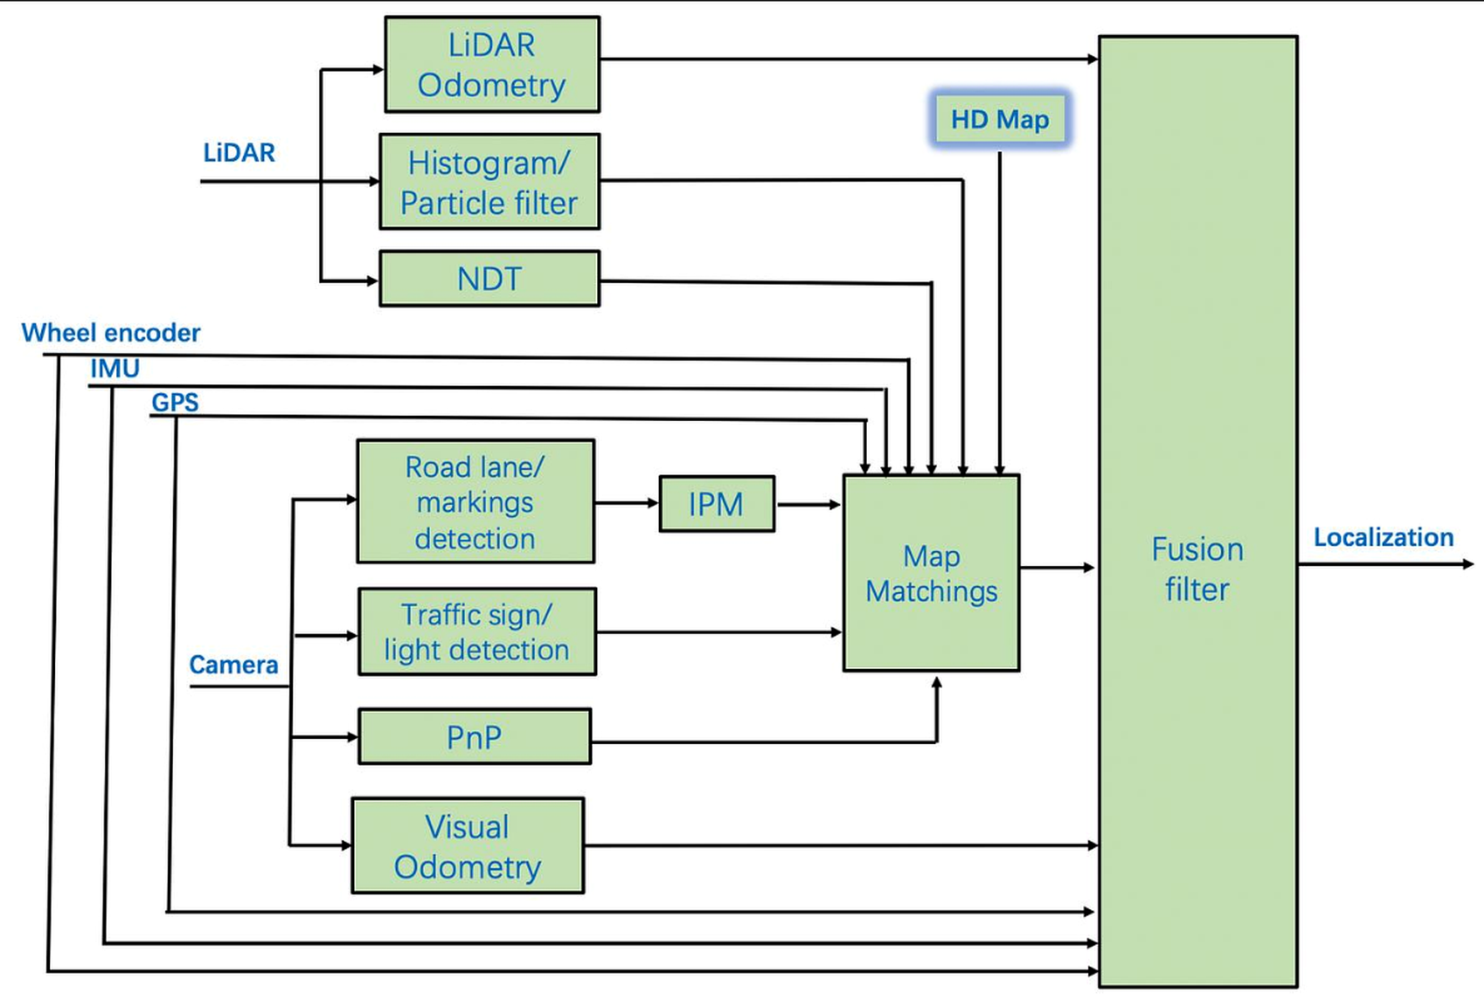
Figure 4. Multi-sensor localization and map-matching framework integrating LiDAR, camera, GPS and IMU data.
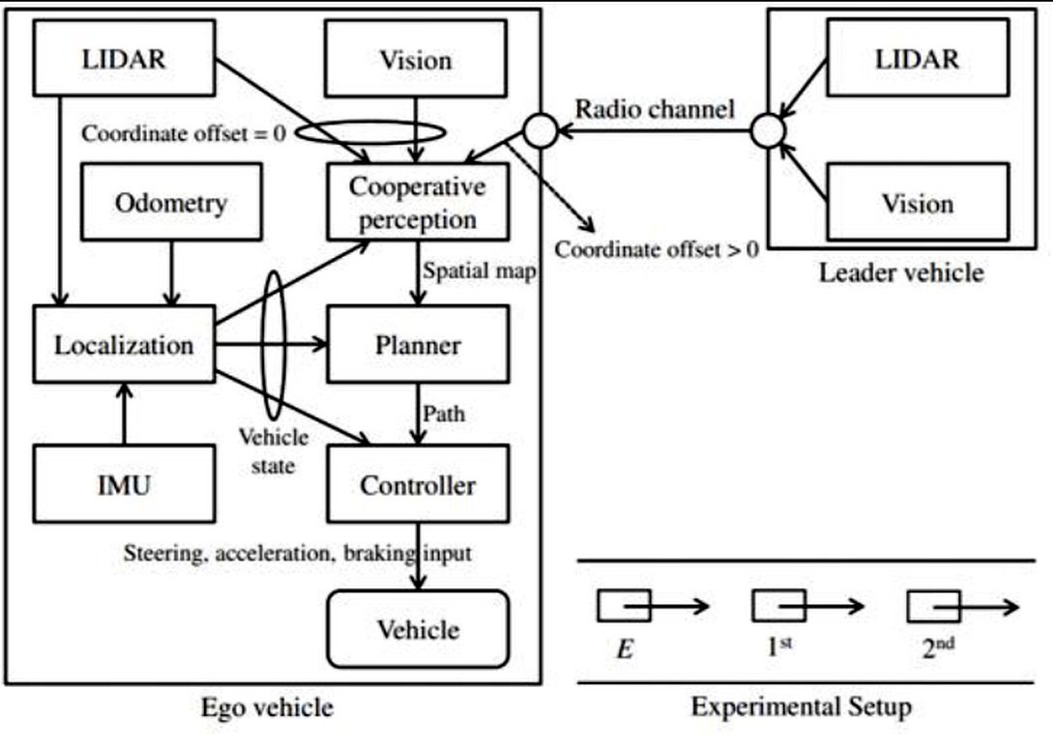
Figure 5. Cooperative perception and control architecture showing sensing, localization, planning and wireless communication.
4. Benefits and Limitations
V2X cooperative perception provides several important benefits for intelligent transportation systems. First, it improves road safety by enabling earlier detection of hazards such as pedestrians, vehicles and obstacles. Second, it extends the perception capability of autonomous vehicles beyond the limitations of onboard sensors. Third, combining information from multiple sources can improve the reliability of autonomous driving decisions.
However, several challenges remain. Communication latency is a critical issue because delayed information may reduce the effectiveness of safety applications. In addition, transmitting large amounts of sensor data, especially raw LiDAR data, requires significant communication bandwidth. Large-scale deployment also requires considerable investment in roadside sensing and communication infrastructure.
Other challenges include localization errors, cybersecurity risks and the difficulty of transferring research results from simulation environments to real-world traffic conditions. Therefore, practical V2X systems must consider not only perception accuracy but also communication reliability and system robustness.
5. Future Development and Engineering Insights
Future V2X cooperative perception systems should focus on achieving a balance between perception accuracy and communication efficiency. Instead of transmitting all raw sensor data, intelligent methods such as edge computing, artificial intelligence-based data compression and selective information sharing can reduce communication requirements while maintaining safety performance.
In addition, more real-world testing is necessary because traffic environments are highly complex and may include different weather conditions, sensor failures, and unpredictable human behaviors. The future development of smart transportation will require the integration of advanced sensing technologies, reliable communication networks and intelligent decision-making algorithms.
From an engineering perspective, V2X should not be considered only as a communication technology. It is a complete cooperative system that connects sensing, data processing, communication and vehicle control. Improving the interaction between these components will be essential for achieving safer and more efficient autonomous transportation systems.
References
[1] R. Xu, H. Xiang, Z. Tu, X. Xia, M.-H. Yang, and J. Ma, “V2X-ViT: Vehicle-to-Everything Cooperative Perception with Vision Transformer,” European Conference on Computer Vision (ECCV), 2022.
[2] F. Huang, H. Chen, A. Urtay, D. Su, W. Wen, and L.-T. Hsu, “Roadside Infrastructure Assisted LiDAR/Inertial-based Mapping for Intelligent Vehicles in Urban Areas,” IEEE 26th International Conference on Intelligent Transportation Systems (ITSC), Bilbao, Spain, 2023.
[3] M. Thabet, A. Bendary, and A. D. Elbayoumy, “Adaptive Autonomous Resource Allocation for 6G V2X Sidelink,” IEEE, 2025.
[4] F. A. Butt, J. N. Chattha, J. Ahmad, M. U. Zia, M. Rizwan, and I. H. Naqvi, “On the Integration of Enabling Wireless Technologies and Sensor Fusion for Next-Generation Connected and Autonomous Vehicles,” IEEE Access, 2022.

